-- TRIGGER TESTS AND THEIR OUTPUTS

**-- HEAD CHEF CAN’T CREATE MORE THAN 9 ITEMS**

-- BAD DATA

INSERT INTO Item (`name`, spice, category, headChef) VALUES

('Chicken Stir Fry', 'Mild', 'Meat Entree Chicken', 5);



-- GOOD DATA

INSERT INTO Item (`name`, spice, category, headChef) VALUES

('Chicken Stir Fry', 'Mild', 'Meat Entree Chicken', 9);



**-- WAITSTAFF CAN’T WAIT ON MORE THAN 5 TABLES**

-- BAD DATA

INSERT INTO TableShift (tableID, employeeID, shiftID) VALUES

(6, 8, 2);



-- GOOD DATA

INSERT INTO TableShift (tableID, employeeID, shiftID) VALUES

(6, 10, 2);

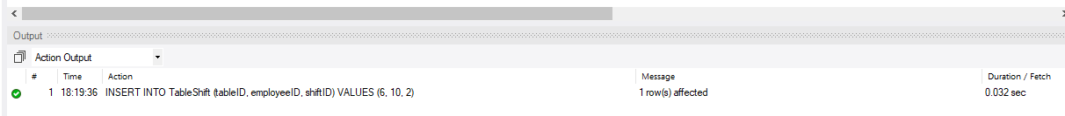

**-- SOUSCHEF CAN’T MENTOR MORE THAN 3 SOUSCHEF MENTEES AT ONCE**

-- BAD DATA

INSERT INTO Mentorship (item, spice, sousChefMentor, sousChefMentee, startDate, endDate) VALUES

('Steamed Chicken Buns', 'Mild', 1, 3, '2020-11-14', null);

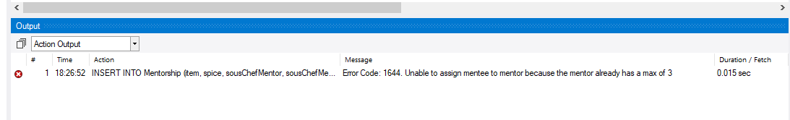

-- GOOD DATA

INSERT INTO Mentorship (item, spice, sousChefMentor, sousChefMentee, startDate, endDate) VALUES

('Steamed Chicken Buns', 'Mild', 2, 3, '2020-11-14', null);



**-- CORP DATA HAS TO BE FILLED IN OR NULL WHEN CREATING A CUSTOMER**

-- BAD DATA

INSERT INTO PaidCustomer (custID, customerName, email, custAddress, mimingsMoney, corpName, corpAddress, corpOrganization, contactInfo) VALUES

(6, 'Person', 'person@gmail.com', '354 person ave', 0, 'Person Inc.' , null, null, null);

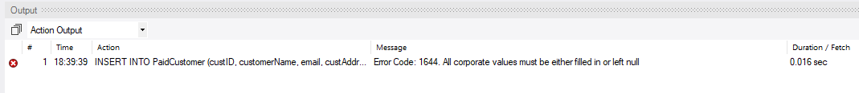

-- GOOD DATA

INSERT INTO PaidCustomer (custID, customerName, email, custAddress, mimingsMoney, corpName, corpAddress, corpOrganization, contactInfo) VALUES

(6, 'Person', 'person@gmail.com', '354 person ave', 0, null, null, null, null);



INSERT INTO PaidCustomer (custID, customerName, email, custAddress, mimingsMoney, corpName, corpAddress, corpOrganization, contactInfo) VALUES

(5, 'Person', 'person@gmail.com', '354 person ave', 0, 'Person Inc', '111 Per st', 'Person Org', '714-341-1453');



**-- Anonymous guests have to pay with cash.**

-- BAD DATA

INSERT INTO `Check` (checkID, paymentType, mimingsMoney, total, custID, `date`) VALUES

(9, 'Credit', 0, 0.0, 10, '2017-12-04');

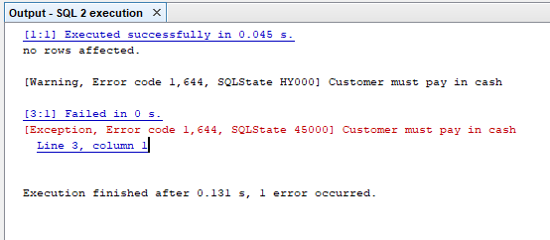

-- GOOD DATA

ALTER TABLE Guest

DROP FOREIGN KEY `guest_ibfk_1`;

INSERT INTO Guest (checkID, guestID) VALUES

(10, 111);

INSERT INTO DineInGuest (guestID, tableID, seatNum) VALUES

(111, 9, 1);

INSERT INTO OrderDetail (guestID, menuType, item, spice, quantity) VALUES

(111, 'Childrens', 'Chinese Beef and Broccoli', 'Mild', 1);

INSERT INTO `Check` (checkID, paymentType, mimingsMoney, total, custID, `date`) VALUES

(10, 'Cash', 0, 2.0, 5, '2020-12-16');

ALTER TABLE Guest ADD CONSTRAINT guest_ibfk_1 FOREIGN KEY (checkID) references `Check` (checkID);

